**COSC 2325 Computer Organization**

**Assignment 8**

**Due: 23:59:00, Oct. 31, 2022**

**Andrew Kalathra**

L20498001

If you use Qtspim simulator:

The starting address of Data Section is 0x10000000.

If you use Mars simulator:

The starting address of Data Section may be 0x10010000

(Please check Settings->Memory Configuration… -> .data base address)

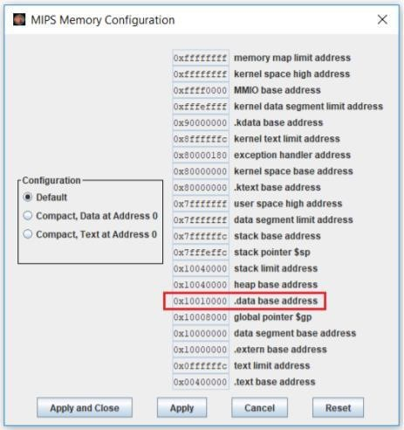

1. Please complete A8_Q1.asm program that computes the average age and average weight. Leave the results in two registers.

.data # data comes in pairs, age and weight pairs: .word 5 # number of pairs

.word 12, 90 # first pair: age, weight

.word 15, 105

.word 32, 256

.word 43, 270

.word 25, 155

19­16= 2510

af16 = 17510

1. What are five rules of Structured Programming?
   1. Code Block – a box with 1 entry and 1 exit is structured
   2. Sequence – 2 or more code blocks in sequence is structured
   3. Alternation – the alternation of two boxes is structured
   4. Iteration – the iteration of a code block is structured
   5. Nesting Structures – the iteration of a code block is structured
2. Please complete the given program, A8_Q3.asm, to compute three sums:

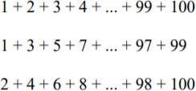

Use a register (say $8) for the sum of evens, a register (say $9) for the sum of odds, and another (say $10) for the sum of all numbers

9f616 = 255010

9c416 = 250010

13ba16 = 505010